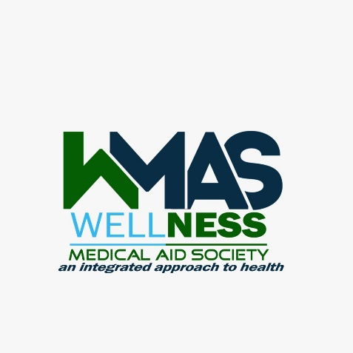
WELLNESS MEDICAL AID SCHEME PRESS PACK – WMAS LAUNCH
FRIDAY 21 AUGUST 2020

OVERVIEW: The generic concept of medical aid is largely based on assisting a member in the event that they are sick and in need of medical attention. Incidentally that comes with a strain on the finances, which usually happens at the wrong end of the month when people don’t have money at hand.
The call for innovative ways to help people in that moment of distress is to take one step backwards and address the most likely causes of medical emergencies and address those fundamentals.
Healthcare services and healthcare funding are elements which address “distress in motion” whereas preventative lifestyle habits will ensure such unfortunate incidences are reduced. Over time when the principle of wellness is passed on from one generation to another a totally new healthy lifestyle will ensure that people live healthy lifestyles – which figuratively and practically “keeps the doctor away”
Most of medical emergencies are caused by what we eat – your health condition is what you put into your body, food.
Wellness Medical Aid Society comes in to push the concept of wellness through lifestyle modelling through an integrated approach to healthcare. The concept involves health education, healthy eating, healthy food solutions to existing medical conditions and networked healthcare services.

VISION: Universal health coverage for all through a well-funded, well governed and well delivered medical system
MISSION: to become the medical aid of choice in giving clients value for money, complementing and pioneering health delivery initiatives thereby reducing the disease burden.
VALUES: Integrity, transparency, accessibility, Affordability

WHAT IS WELLNESS MEDICAL AID SOCIETY?
- Imagine avoiding a doctor in the first place.
- Imagine seeing a doctor for your routine consultation and investigations without any illness.
- Imagine a lifestyle founded on a preventative lifestyle
- Wellness Medical Aid Society is an organisation offering an integrated approach to healthcare. This concept comes packaged to provide real solutions to healthcare as a lifestyle – not managing the incidences associated with health seeking behaviour after falls sick.
- WMAS is targeting the previously exposed, vulnerable and uninsured and those under-insured. Currently only about 10% of Zimbabweans are on some medical aid cover and the rest remain vulnerable. Individuals, households and corporate organisations can join the scheme.

SCHEME CHARACTERISTICS
- One needs to watch their health as a lifestyle – your health is a result of what you eat and how you take care of your body on a daily basis.
- Members will have access to healthy foods and dietary consultations at identified “Wellness Centres”
- Networked healthcare service providers emphasising on preventative medicine and lifestyle care.
- Members will be identified by personalised membership cards.
- Reliability – this provides assured access to both healthy food and critical healthcare service providers at point of need to all citizens.
- Affordability – premiums are affordable and payable in any legal currency in Zimbabwe.
- A principal member register as many dependants as they wish. Children above 18 can have their own membership status.
- Schemes are identified by different fruits and offering benefits on a sliding scale relative to the subscriptions paid.

APPLICABLE LIFESTYLE CENTRES
WMAS members will get access to doctors, medical facilities, wellness centres and healthy food outlets at discounted rates.
REGISTRATION PROCESS
- Fill in an application form and get a membership number allocated. Personalised membership cards given out to all registered members.

VALUE ADD BENEFITS:
- Cash back – hybrid product comprising insurance and savings where members get 25% of their low claims account balances back after two years continuous membership as a low claims bonus.
- Wellness Programs: Open Wellness centres established to offer both treatment and rehabilitation programs for clients through medical testing, counseling, professional advice, physical wellbeing and health economics education.
- Health Restaurants: public restaurants offering healthy foods and cooking lessons to enhance members’ total health lifestyle.
- Funeral Rider Benefit: an additional life policy cover underwritten by a life insurer partner

CORPORATE OVERVIEW:
The society is under the care and executive management of Mr. Kudakwashe Munyongwa who is the Principal Officer, who is a dynamic, diligent, dedicated and professional accountant. He brings in wide experience at both technical and operational level to drive the business with great influence.
The society is also led by a team board members drawn from various fields of expertise and experience including medical practitioners.
The driving value of Wellness Medical Aid Society is to give equal access to healthcare to all members of the society.
CONTACT DETAILS:
Wellness Medical Aid Society – Head Office: 21 School Avenue, Gweru, Zimbabwe.  Phones: +263 542229628/9 or +263713420235 or +263772870796.  Email: kmunyongwa@wmas.co.zw. (Principal Officer)  Website: www.wmas.co.zw | CONSULTING PARTNERS:  Stanrosa Business Associates – 406 Exploration House, cnr Robert Mugabe/5th Street Harare, Zimbabwe.  Phones: +263 242795951 or +263772415660.  Email: joe@stanrosa.co.zw (Senior Consulting Executive)  Website: www.stanrosa.co.zw

